

Bansilal Ramnath Agarwal Charitable Trust’s

# Vishwakarma Institute of Information Technology

Business Intelligence and Data Analytics

(Assignments 5)

|  |  |  |  |
| --- | --- | --- | --- |
| Name | Roll No. | GR No. | Batch |
| Chetan Chinchulkar | 324017 | 21810350 | E9 (Comp D) |
| Nikit Gokhe | 324022 | 21810522 | E9 (Comp D) |
| Sahil Langha | 324032 | 21810533 | E9 (Comp D) |
| Kunal Parkhe | 324040 | 21810049 | E9 (Comp D) |

GROUP MEMBERS:

# Assignment No. 05

# Aim:

Perform Visual analytics using Tableau. Plot various graph like table plot, histogram, boxplot for the suitable data and create a dashboard for the same.

# Objective:

To create a dashboard using Tableau.

# Theory:

A dashboard is a collection of several views, letting you compare a variety of data simultaneously. For example, if you have a set of views that you review every day, you can create a dashboard that displays all the views at once, rather than navigate to separate worksheets.

Like worksheets, you access dashboards from tabs at the bottom of a workbook. Data in sheets and dashboards is connected; when you modify a sheet, any dashboards containing it change, and vice versa. Both sheets and dashboards update with the latest available data from the data source.

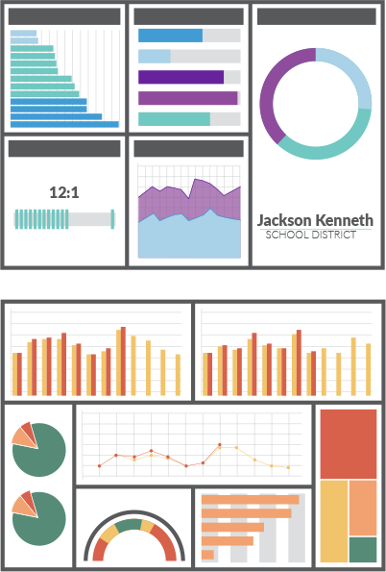

# Input:

**Name:** countrywise_covid_data.csv

**Dataset Reference:** kaggle

# 

# Output:

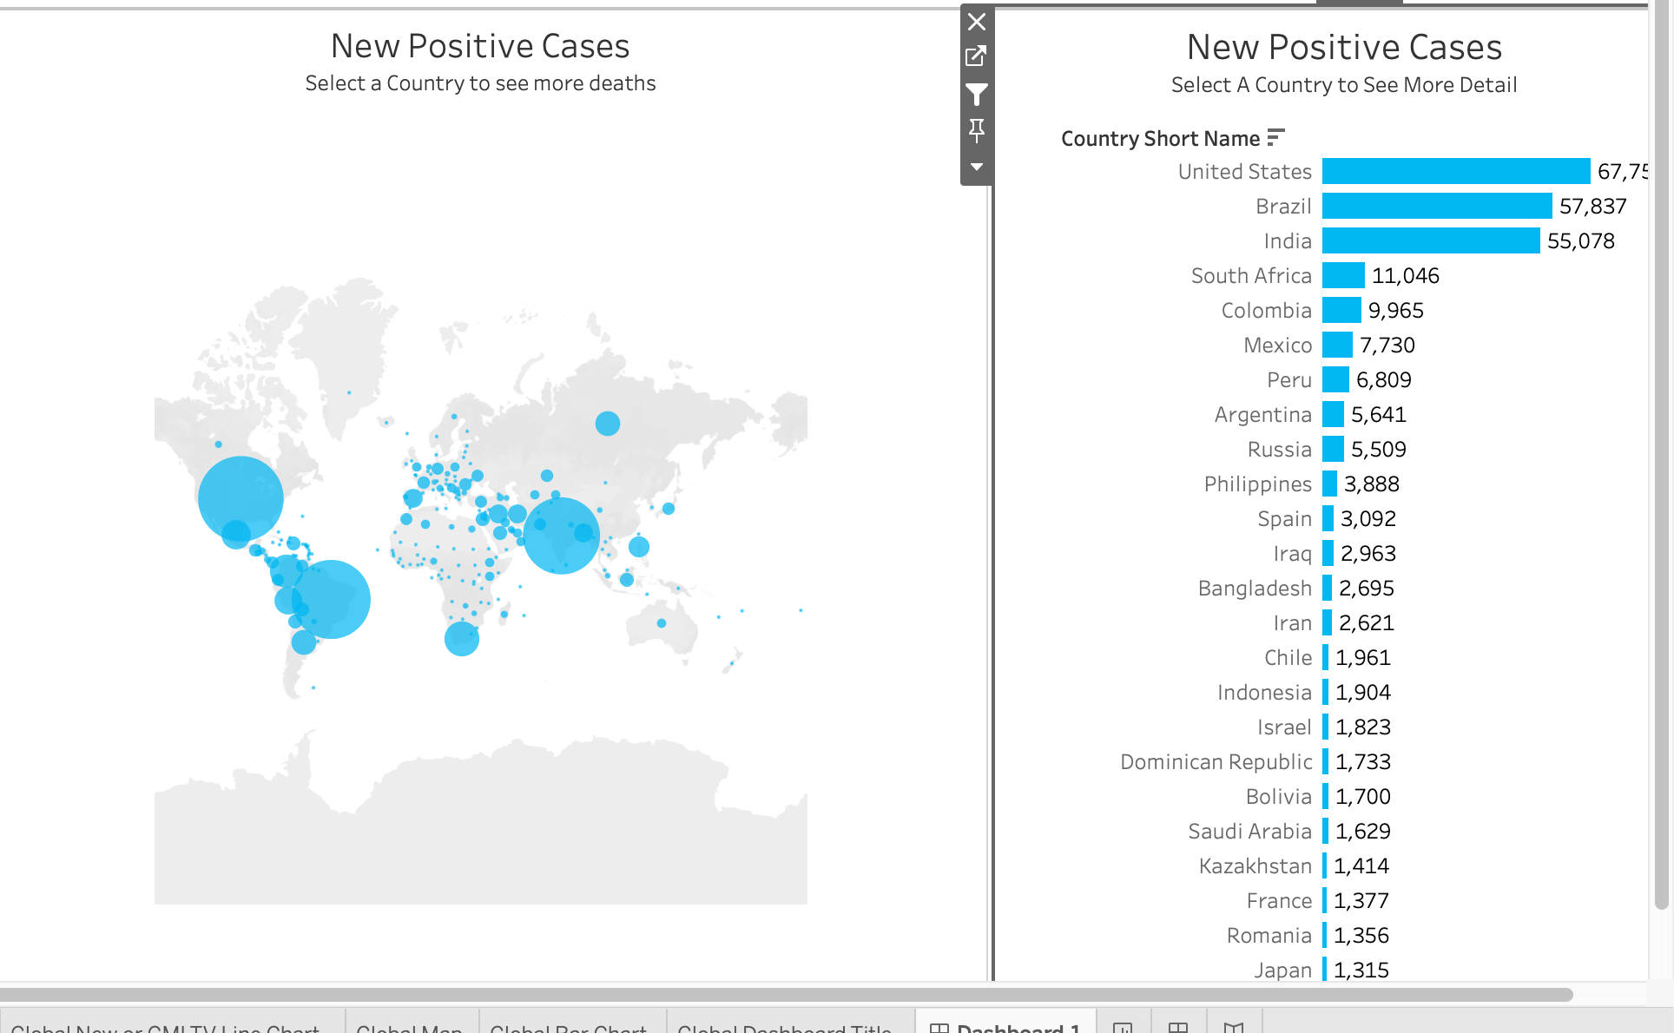

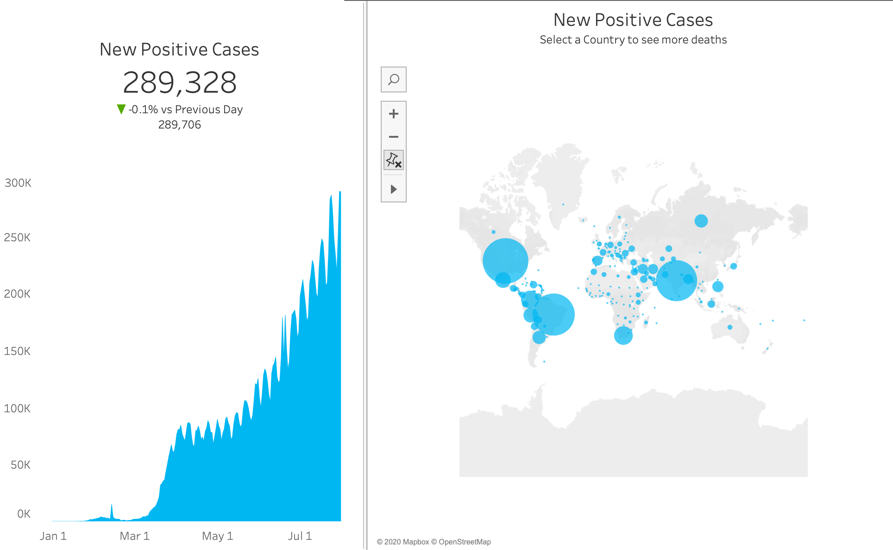

# Inference:

1. The Sheet where the global Map is shown represents the intensity of the cases in the particular country with respect to the size of the bubble that is over them.
2. The bar graph represents the number of new positive cases in the particular country.
3. The final graph shows the number of new positive cases with respect to dates. Also thus stats will show you the cases that occurred on a particular date in a particular country when you chose the country from the horizontal bar graph.

# Conclusion:

We have created a dashboard Using Tableau which gives up a detail look upon the rising number of cases in various countries and the number of cases increasing each day in a particular country using The_countrywise_covid_data.csv.